Questions:

1. Average Ratings over time is there a trend? Are audiences becomes more critical or not.
2. Genre popularity over time
3. Critic review vs audience review => box office
4. Top movies by box office, then count of actors, who are popular actors
5. Time of release affect box office? (t-test)
6. Which Studios are most successful
7. Successful directors
8. MPAA Ratings – do the ratings play a part in box office or audience ratings

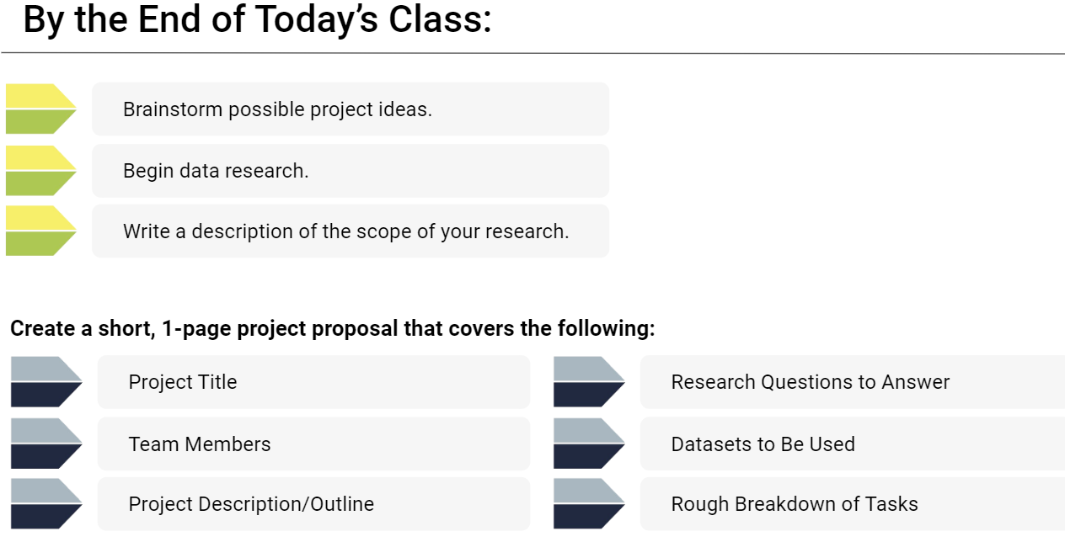

**Project Title:** Critic/Audience Reviews vs Movie Success

**Project Description:** Analyze impact of critic and audience reviews on movie’s earnings. Which opinion matters more or do they have any impact at all. Check films where audiences and critics disagree, and see which one holds more weight for success.

**Datasets:** <http://www.omdbapi.com/>; Open Critic

Tasks:

**Project Title:** How do student loans impact (spending habits,

**Project Description:** What factors result in high student loans and how do student loans impact important life milestones (eg. Age of buying a house, age at marriage, having kids)

**Data sets: data.gov:** housing, student loans, us census,

---------------------------

Variables to store:

1. Actors

2. Box Office

3. Director

4. Genre

5. Metascore

6. Production

7. Rated

8. Ratings

9. Released

10. Year

11. imdbID

12. imdbRating

13. imdbVotes

14. Runtime